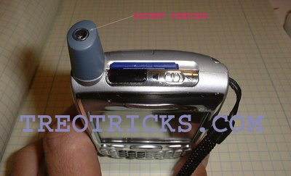

Wednesday, December 07, 2005
Add an Extra Audio Jack to Your Treo, Part 3.
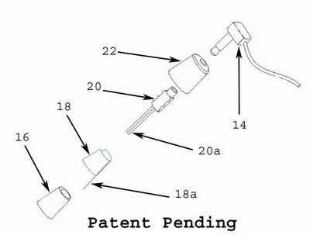
This is the final how-to for the Antenna Jack Hack. I do have one more how-to for modifying the antenna element 18, but that will come at a later date after more testing. My intent is to optimize the antenna for 1900 MHz spectrum.

Please read the entire article to make sure you know what you are getting into and understand the proceedure. To get the antenna ready for installation, you will need to enlarge the hollow area of the antenna core 16 and also drill a hole for the audio jack wires 20a, you will need to solder 18 and 18a together, cut and trim down the audio jack 20 and solder the wires 20a, and to cut an acess hole in the antenna cover 22.

The tools needed for the job are:
- T5 Torx driver.
- x-acto knife.
- Small wire cutters.
- Soldering tool.
- Light duty rosin core solder.
- 26 guage stranded wire, red, white and black.
- Audio jack, Kycon P/N ST-3500-3N.
- Dremel tool.
- Dremel cutting bits, 1/8" & 3/32"
- hand drill or low power drill.
- Drill bits, 0.195", 0.125" & 0.060"
- Small rat tail file.
- Small hammer.
- Donor Antenna.
First thing you need to do is disassemble the donor antenna, this is done by drilling the top of the antenna with a 0.125" drill bit. Drill the hole right in the middle until you break thru. Then remove the bit and insert it into the drilled hole all the way down. Find a nice hard, sharp edge on a workbench or vise or anything else that will work. Place the antenna cover lip on the edge as shown in the picture below and give the drill bit a good whack to remove the antenna core from the cover.
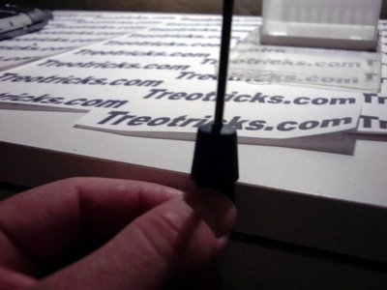

Below is a picture of the 2 pieces separated.
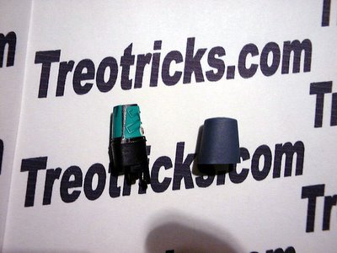
Now you need to remove the actual antenna, screw, and antenna contact. After removing the screw, you need pull up on the gold plated antenna contact and pull it out. Remember how it comes out, so you do not try to insert it in backwards later. Now unpeel the antenna and set it aside. Try not to contaminate the adhesive since it will be reusable.
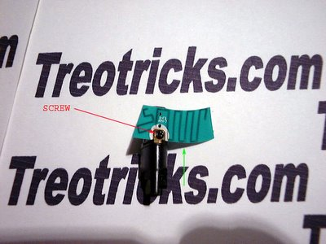
Now here comes the hard part, cutting away at the antenna core and audio jack. Although a 4 pole 2.5mm audio jack fits perfectly in the antenna core, the Treo already has one of those. You can use a 2.5mm jack if you don't want to cut away any plastic.
When cutting, remember that the more you cut on one, the less you need to cut on the other. I is a good idea to have at least extra jacks and maybe an extra antenna. I have ruined a couple but now I can do them in my sleep. Just work slowly and jump back and forth to make sure you do not cut too much. I recommend cutting at slow speeds.... 25K RPMs is way too fast. Start with the bigger bit and switch to the smaller one to finish up.
For cutting away material, work on making the hole in the antenna core square and trying to make the audio jack round. Start by cutting the tabs off the audio jack and rounding the corners. You may have to get a bit agressive and cut into the contacts but don't worry, they are relativly secure. Next cut 3 sides off of the end as indicated in the picture below, labled "shorten". You will need to cut about 1/8" on the sides with no metal. You will also need to cut about 1/16" or more of the contact for the connector tip on the 4th side. Also cut the groove shown in the picture. Also take some material off of the top side of the connector, from where the "cut groove" arrow is to the left. After cutting the jack... it doesn't even look the same.
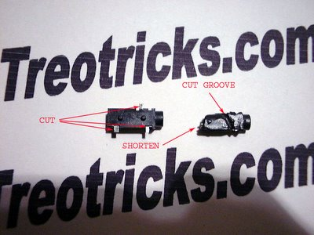
Now jump to the antenna core. Start by converting the semi-round into a square. Cut away at the corners and make them sharper. Try not to cut away material from the side where the screw goes it. Even though the screw will not be reused, that side is the strongest and does most of the support. Also, at the bottom of the hole there is a protrusion also on the side of the screw hole. Try not to remove any material from there because if you do, you might pick up noise from the antenna. That protrusion is the channel that the gold plated antenna contact sits in. Below is a picture showing how much is cut. Also note the hole for the jack wires.
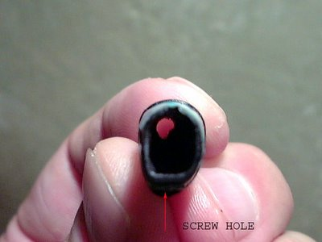
Once you think you cut enough from both pieces, try to see if the jack slides into the core. don't use too much force, it should slide in snug but not too snug. Make sure that when you insert the jack in, it is oriented with the contact for the tip (white wire) on the opposite side from where the screw hole is. The jack should go in almost all the way in, with just the round portion of the jack sticking up.
Once you think you have cut enough material from both pieces, it time to solder on the wires. The pieces should be at least 4" (10 cm) long. The black wire goes closer to the insertion hole and sits in the channel. Make sure that the portion of the wire does not have insulation, otherwise the jack might not go in. The red wire goes on the middle contact and the white wire goes on the tip contact. There might not be too much metal on the tip contact, so be very careful that after soldering, the jack still functions. You should check the jack many times throughout the assembly process. below is a picture of what the jack should look like all wired up. Wires look a bit beat up since this is a prototype that has been worked on a bunch.
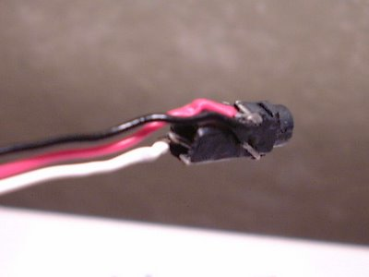
Now insert the wires and the jack in the antenna core. Do not be too forcefull, you can still cut away some material. If you are having a hard time removing the jack because it is stuck, use a pick or someting similar and insert it via screw hole and pry out the jack. Once you get a good fit you should seal up the screw hole to insulate the audio jack from the antenna. I used some plastic and an old solder tip and heated up a small piece until it was soft, then I covered up the hole and cut away the excess once it hardened.
Now go ahead and stick the antenna back on and then insert the gold plated antenna contact back in where it goes. Since the screw no longer can be used, you will need to solder the 2 pieces together. Just break off a piece of solder and place it between the 2 pieces and heat the contact until the solder flows and then bonds together.
You are now ready to put the cover back on. This process can take up to an hour or more... and that is with practice and experience. I have a tool and a drill press to drill it just right, but you should file and cut a little bit at a time, checking after every cut to make sure you get a perfect fit. If you think you have it centered pretty good, you can use the correct sized drill bit and be done with it.
Place the cover on how it is suppose to go on for placement check and backwards (or with another jack) to see if it is the right size hole. Once you think you have it right, squeeze the 2 halves togheter until they snap together.... and stand back and admire your work. Good JOB!!
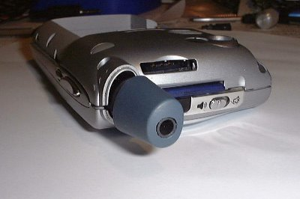
It ther are any errors or suggestions or questions please let me know via email. I have received some questions but with no return email address.
Up next, optimizing the antenna for 1900 MHz, an increase in battery capacity, integrated hotsync button and even better hacks than this one... stay tuned!!!

