Mau Mau

Overview
Mau Mau is a classic card game of two to four players on your Palm screen.
The game is played against three AI opponents, so that total four players participate in the game. The player may choose in menu also different number of players from two to four, and select which players should be present.

Player's cards are located at the bottom of screen. The game is turn-based, each time a player moves, (s)he either plays card from hands, or takes card from the base pile. The goal of the game is to get rid of all cards from the hand. (Note that this description doesn't supplement actual game rules, which are not described here, but are completely described in game's help screen).

After winning a round, the winner gets points, and the game continues with next turn, until one of players reaches such amount of points, that the game is over. The round winners are rewarded after each round, as well as the winner of the game is rewarded when the game is over. The reward is in a form of special item placed in front of winner, and satisfaction from seeing the opponents being deadly sad that they have not won.

The opponents have animated parts of face in order to show their emotions. This includes eyes, mouth, and some figures have special animations (e.g. the boy uses sticking out his tongue when making good turn).

Screenshots

 | 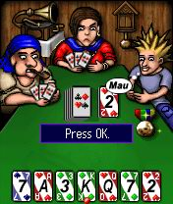
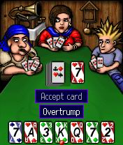 | 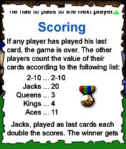  Comprehensive rules  included.

Features

- Well known card game
- Colorful graphics
- Funny opponents
- Background music
- Sound effects
- Hours of fun

Links
Several web sites offer rules for Mau-Mau card game, each with slight variations:
Mau: A Card Game of Memory, Reflexes, and Patience
Mau Mau Tadhg´s page
Mau - Mau Game rules
Mau Mau Regeln

Requirements
Palm OS 5
320x320 high-density screen

Copyright (c) Lonely Cat Games

